**Classic BT VS BTLE**

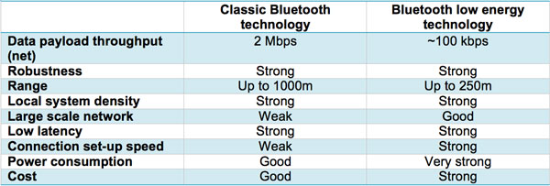

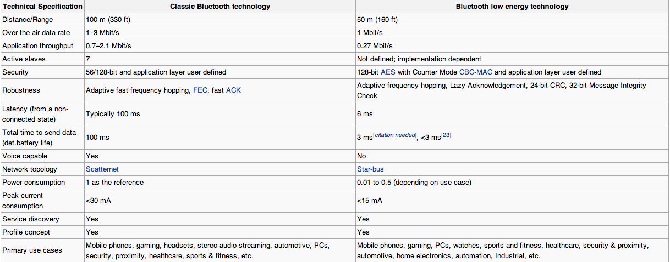

There are different specifications for LE and classic BT as shown above but the general trends remain the same.

Benefits of LE for our project

* Power consumption (as little as ~1 uA current consumed on average, assuming lots of sleep time)
* Cost
* Supported by iPhone and most androids
* Size
* Proximity feature?

Disadvantages of LE for our project

* Range (not really a factor for our project)
* Data rate (probably not a factor for our project as well)

<http://www.medicalelectronicsdesign.com/article/bluetooth-low-energy-vs-classic-bluetooth-choose-best-wireless-technology-your-application>

Paper on BTLE and zigbee: <http://chapters.comsoc.org/vancouver/BTLER3.pdf>

**Limitations of LE/compatibility**

Limitations

The only real limitations of LE are in applications of high data transfer rates or data streaming. LE is aimed to focus on the power consumption instead of the transfer rates that BT 2.0 and 3.0 were aimed at enhancing. The progression towards dual band BT (supporting classic as well as LE) is where most of the major BT chip manufacturers have headed. Non-dual mode chips are now going to be legacy devices as everything new supports LE.

<http://www.eetimes.com/document.asp?doc_id=1278966>

Compatibility

Almost all smartphones now support LE with the most notable for our project being the iPhone.

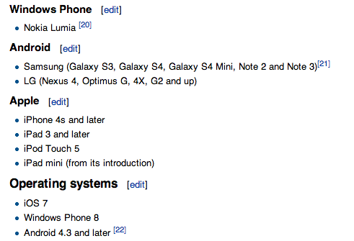

**BT Chipsets**